**Branch: - Computer Science and Engineering Class: - III Year**

**Subject: - C-Skill Lab-IV Sem: - VI**

**Teacher Manual**

**PRACTICAL NO. 1**

**Aim:** Study and implement Linux commands

**1) pwd Command**

The pwd command is used to display the location of the current working directory

**Syntax:** pwd

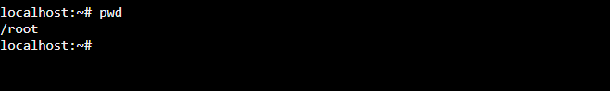

**2) mkdir Command**

The [mkdir:](https://www.javatpoint.com/linux-mkdir) Command is used to create a new directory under any directory.

**Syntax:** mkdir **<directory** name**>**

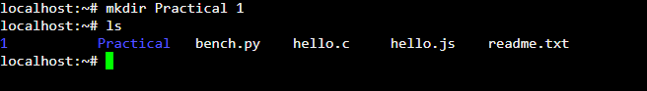

**3) rmdir Command**

The rmdir command is used to delete a directory.

Syntax: Syntax: rmdir <directory name>

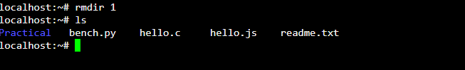

**4) ls Command**

The ls command is used to display a list of content of a directory.

**Syntax:** ls

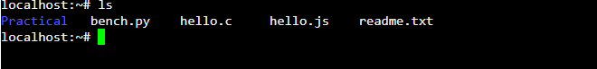

**5) cd Command**

The cd command is used to change the current directory.

**Syntax:** cd **<directory** name**>**



**6) touch Command**

The touch command is used to create empty files. We can create multiple empty files by executing it once.

**Syntax:** touch **<file** name**>**

touch **<file1>**  **<file2>** ....

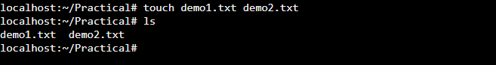

**7) cat Command**

The cat command is a multi-purpose utility in the Linux system. It can be used to create a file, display content of the file, copy the content of one file to another file, and more.

**Syntax:** cat [OPTION]... [FILE]..

To create a file, execute it as follows

cat > <file name>   // Enter file content

Press "CTRL+ D" keys to save the file. To display the content of the file, execute it as follows

cat <file name>

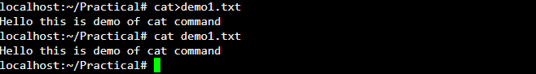

**8) rm Command**

The rm command is used to remove a file

**Syntax:** rm <file name>

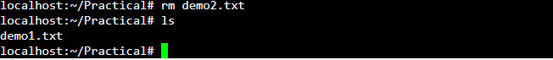

**9) cp Command**

The cp command is used to copy a file or directory

**Syntax:** To copy in the same directory

cp <existing file name> <new file name>

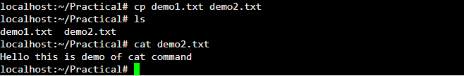

**10) mv Command**

The mv command is used to move a file or a directory form one location to another location

**Syntax:** mv **<file** name**>** **< file** name **>**

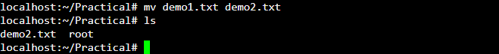

**11) head Command**

The head command is used to display the content of a file. It displays the first 10 lines of a file

**Syntax:** head **<file** name**>**



**12) tail Command**

The tail command is similar to the head command. The difference between both commands is that it displays the last ten lines of the file content. It is useful for reading the error message

**Syntax:** tail **<file** name**>**



**13) tac Command**

The tac command is the reverse of cat command, as its name specified. It displays the file content in reverse order (from the last line).

**Syntax:** tac **<file** name**>**

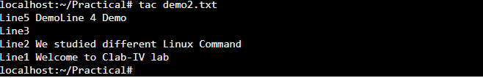

**14) passwd Command**

The passwd command is used to create and change the password for a user

**Syntax:**  passwd **<username>**

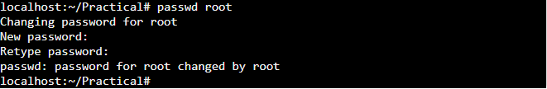

**Result:** Thus, we have studied and implement Linux commands